GAME OVER.

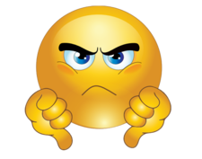YOU LOSE!

GAME OVER.

YOU WIN!



GAME OVER.

IT A TIE!

